- Exercise 1: Build and run applications that use "Set" Collection objects
- Exercise 2: Build and run applications that use "List" Collection objects
- Exercise 3: Build and run applications that use "Map" Collection objects
- Exercise 4: Iterator
- Exercise 5: Algorithms
- Homework

Exercise 1: Build and run "Set" Collection Objects

The Set interface extends the Collection interface and, by definition, forbids duplicates within the collection. All the original methods are present and no new methods are introduced. The concrete Set implementation classes rely on the equals() method of the object added to check for equality.
The Collections Framework provides two general-purpose implementations of the Set interface: HashSet and TreeSet. More often than not, you will use a HashSet for storing your duplicate-free collection. For efficiency, objects added to a HashSet need to implement the hashCode() method in a manner that properly distributes the hash codes. While most system classes override the default hashCode() implementation in Object, when creating your own classes to add to a HashSet remember to override hashCode(). The TreeSet implementation is useful when you need to extract elements from a collection in a sorted manner. In order to work property, elements added to a TreeSet must be sortable. The Collections Framework adds support for Comparable elements and will be covered in detail later. For now, just assume a tree knows how to keep elements of the java.lang wrapper classes sorted. It is generally faster to add elements to a HashSet, then convert the collection to a TreeSet for sorted traversal.
To optimize HashSet space usage, you can tune the initial capacity and load factor. The TreeSet has no tuning options, as the tree is always balanced, ensuring log(n) performance for insertions, deletions, and queries.
Tasks to be performed:
- Build and run an application that uses HashSet
- Find duplication via HashSet
- Find duplication via HasetSet 2
- Build and run an application that uses TreeSet
- Build and run an application that uses LinkedHashSet
- Set and polymorphism

(1.1) Build and run an application that uses HashSet
In this step, you are going to build an application that uses HashSet. You are going to exercise various methods of the HashSet class. The following is quoted from online JavaDoc of the HashSet
This class implements the Set interface, backed by a hash table (actually a HashMap instance). It makes no guarantees as to the iteration order of the set; in particular, it does not guarantee that the order will remain constant over time. This class permits the null element.
This class offers constant time performance for the basic operations (add, remove, contains and size), assuming the hash function disperses the elements properly among the buckets. Iterating over this set requires time proportional to the sum of the HashSet instance's size (the number of elements) plus the "capacity" of the backing HashMap instance (the number of buckets). Thus, it's very important not to set the initial capacity too high (or the load factor too low) if iteration performance is important.
0. Start NetBeans IDE if you have not done so yet.
1. Create a new NetBeans project
- Select File->New Project (Ctrl+Shift+N). The New Project dialog box appears.
- Under Choose Project pane, select Java under Categories and Java Application under Projects.
- Click Next.
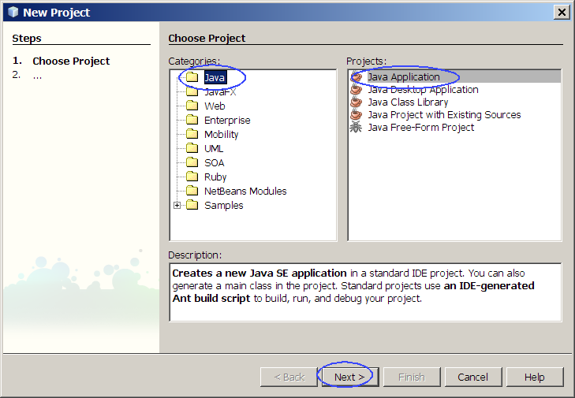
- Under Name and Location pane, for the Project Name field, type in Set-HashSet-add as project name.
- For Create Main Class field, take the default value sethashsetadd.Main provided by the IDE.
- Click Finish.
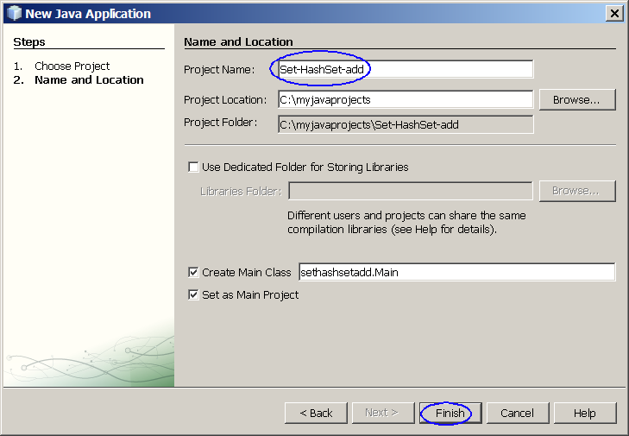
Figure-1.10: Create a new project
- Observe that Set-HashSet-add project appears and IDE generated Main.java is displayed in the source editor window of NetBeans IDE.
2. Modify the IDE generated Main.java as shown in Code-1.10 below. Study the code by paying special attention to the bold fonted comments.
package sethashsetadd;
import java.util.HashSet;
public class Main {
public static void main(String[] args) {
// Create HashSet object
HashSet hs = new HashSet(5, 0.5f);
System.out.println(hs.add("one"));
System.out.println(hs.add("two"));
System.out.println(hs.add("three"));
System.out.println(hs.add("four"));
System.out.println(hs.add("five"));
// Print out the HashSet object
System.out.println(hs);
// Add a duplicate item to the HashSet
Boolean b = hs.add("one");
System.out.println("Duplicate item allowed = " + b);
System.out.println(hs);
}
}
Code-1.10: Modified Main.java
3. Build and run the project
- Right click Set-HashSet-add project and select Run.
- Observe the result in the Output window. (Figure-1.11 below)
true
true
true
true
true
[one, two, five, three, four]
Duplicate item allowed = false
[one, two, five, three, four]
Figure-1.11: Result of running Set-HashSet-add application
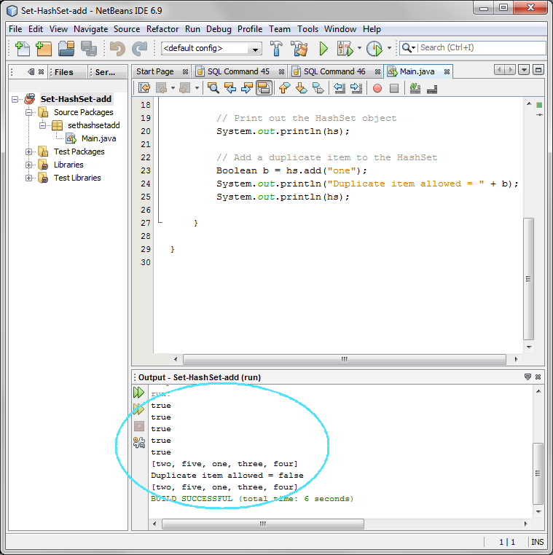
Trouble-shooting and solution: If you are seeing the following warning message during compilation, that is expected behavior. This warning message is generated by javac compiler since you are not specifying the type of the collection using Generics. For now, just ignore the message.
- Compiling 1 source file to C:\ej_java\Main.java uses unchecked or unsafe operations.
Note: Recompile with -Xlint:unchecked for details.

4. For your own exercise, please do the following
- Create your own NetBeans project named as MyHashSet
- Create your own HashSet object with initial capacity of 5
- Add the following objects to the newly created HashSet object
  - 2 String objects
  - 2 MyOwnClass object (You will have to create MyOwnClass.java first)
  - 3 Integer objects
- Display the HashSet object
return to top of the exercise

(1.2) Find duplication via HashSet
1. Create a new NetBeans project
- Select File->New Project (Ctrl+Shift+N). The New Project dialog box appears.
- Under Choose Project pane, select Java under Categories and Java Application under Projects. Click Next.
- Under Name and Location pane, for the Project Name field, type in Set-HashSet-FindDup as project name.
- For Create Main Class field, take the default value sethashsetfinddup.Main provided by the IDE.
- Click Finish.
- Observe that Set-HashSet-FindDup project appears and IDE generated Main.java is displayed in the source editor window of NetBeans IDE.
2. Modify the IDE generated Main.java as shown in Code-1.20 below. Study the code by paying special attention to the bold fonted part.
package sethashsetfinddup;
import java.util.HashSet;
import java.util.Set;
public class Main {
public static void main(String[] args) {
// Set up test data
String name[] = {
new String("Sang"),
new String("Shin"),
new String("Boston"),
new String("Shin")
};
// Create HashSet object instance and
// assign it to a variable of Set type.
Set s = new HashSet();
for (int i=0; i<name.length; i++)
if (!s.add(name[i]))
System.out.println("Duplicate detected: "+name[i]);
System.out.println(s.size()+" distinct words detected: "+s);
}
}
Code-1.20: Modified Main.java
3. Build and run the project
- Right click Set-HashSet-FindDup project and select Run.
- Observe the result in the Output window. (Figure-1.21 below)
Duplicate detected: Shin
3 distinct words detected: [Shin, Sang, Boston]
Figure-1.21: Result of running Set-HashSet-FindDup application
4. For your own exercise, please do the following tasks:
- Modify Main.java as following
  - Create your array of Strings called myownnames[] with duplicates
  - Create a HashSet object from the array and display it and make sure there is no duplcates in the set.
return to top of the exercise

(1.3) Find duplication via HashSet 2
In this step, you are going to exercise removeAll() method.
1. Create a new NetBeans project
- Select File->New Project (Ctrl+Shift+N). The New Project dialog box appears.
- Under Choose Project pane, select Java under Categories and Java Application under Projects. Click Next.
- Under Name and Location pane, for the Project Name field, type in Set-HashSet-FindDup2 as project name.
- For Create Main Class field, take the default value provided by the IDE.
- Click Finish.
- Observe that Set-HashSet-FindDup2 project appears and IDE generated Main.java is displayed in the source editor window of NetBeans IDE.
2. Modify the IDE generated Main.java as shown in Code-1.30 below. Study the code by paying special attention to the bold fonted part.
package sethashsetfinddup2;
import java.util.HashSet;
import java.util.Set;
public class Main {
public static void main(String[] args) {
// Set up test data
String name[] = {
new String("Sang"),
new String("Shin"),
new String("Boston"),
new String("Shin")
};
Set uniques = new HashSet();
Set dups = new HashSet();
for (int i=0; i<name.length; i++)
if (!uniques.add(name[i]))
dups.add(name[i]);
// Remove items that duplicates
uniques.removeAll(dups);
System.out.println("Unique words: " + uniques);
System.out.println("Duplicate words: " + dups);
}
}
Code-1.30: Modified Main.java
3. Build and run the project
- Right click Set-HashSet-FindDup2 project and select Run.
- Observe the result in the Output window. (Figure-1.31 below)
Unique words: [Sang, Boston]
Duplicate words: [Shin]
Figure-1.31: Result of running Set-HashSet-FindDup2 application
4. For your own exercise, please do the following tasks:
- Modify Main.java or create your own project as following
  - Create your array of Strings called myownnames[] with duplicates
  - Create two HashSet objectts and use removeAll() method to remove items that have duplicates from the original set.
  - Display the two HashSet objects
return to top of the exercise

(1.4) Build and run an application that uses TreeSet
In this step, you are going to build an application that uses TreeSet. You are going to exercise various methods of the TreeSet class. The following is quoted from online JavaDoc of the TreeSet
This class implements the Set interface, backed by a TreeMap instance. This class guarantees that the sorted set will be in ascending element order, sorted according to the natural order of the elements (see Comparable), or by the comparator provided at set creation time, depending on which constructor is used.
This implementation provides guaranteed log(n) time cost for the basic operations (add, remove and contains).
Note that the ordering maintained by a set (whether or not an explicit comparator is provided) must be consistent with equals if it is to correctly implement the Set interface. (See Comparable or Comparator for a precise definition of consistent with equals.) This is so because the Set interface is defined in terms of the equals operation, but a TreeSet instance performs all key comparisons using its compareTo (or compare) method, so two keys that are deemed equal by this method are, from the standpoint of the set, equal. The behavior of a set is well-defined even if its ordering is inconsistent with equals; it just fails to obey the general contract of the Set interface.
1. Create a NetBeans project
- Select File->New Project (Ctrl+Shift+N). The New Project dialog box appears.
- Under Choose Project pane, select Java under Categories and Java Application under Projects. Click Next.
- Under Name and Location pane, for the Project Name field, type in Set-TreeSet as project name.
- For Create Main Class field, take the default value provided by the IDE.
- Click Finish.
- Observe that Set-TreeSet project appears and IDE generated Main.java is displayed in the source editor window of NetBeans IDE.
2. Modify the IDE generated Main.java as shown in Code-1.40 below.
package settreeset;
import java.util.Set;
import java.util.TreeSet;
public class Main {
public static void main(String[] args) {
Set ts = new TreeSet();
ts.add("one");
ts.add("two");
ts.add("three");
ts.add("four");
ts.add("three");
System.out.println("Members from TreeSet = " + ts);
Set ts2 = new TreeSet();
ts2.add(1);
ts2.add(2);
ts2.add(3);
ts2.add(4);
ts2.add(2);
System.out.println("Members from TreeSet = " + ts2);
}
}
Code-1.40: Modified Set-TreeSet.java
3. Build and run the project
- Right click Set-TreeSet project and select Run.
- Observe the result in the Output window. (Figure-1.41 below)
[Members from TreeSet = [four, one, three, two]
Members from TreeSet = [1, 2, 3, 4]
Figure-1.41: Result of running Set-TreeSet application
return to top of the exercise

(1.5) Build and run an application that uses LinkedHashSet
1. Create a new NetBeans project
- Select File->New Project (Ctrl+Shift+N). The New Project dialog box appears.
- Under Choose Project pane, select Java under Categories and Java Application under Projects. Click Next.
- Under Name and Location pane, for the Project Name field, type in Set-LinkedHashSet as project name.
- For Create Main Class field, take the default value provided by the IDE.
- Click Finish.
- Observe that Set-LinkedHashSet project appears and IDE generated Main.java is displayed in the source editor window of NetBeans IDE.
2. Modify the IDE generated Main.java as shown in Code-1.50 below. Study the code by paying special attention to the bold fonted part.
package setlinkedhashset;
import java.util.LinkedHashSet;
import java.util.Set;
public class Main {
public static void main(String[] args) {
Set ts = new LinkedHashSet();
ts.add("one");
ts.add("two");
ts.add("three");
ts.add("four");
ts.add("two");
System.out.println("Members from LinkedHashSet = " + ts);
Set ts2 = new LinkedHashSet();
ts2.add(2);
ts2.add(1);
ts2.add(3);
ts2.add(3);
System.out.println("Members from LinkedHashSet = " + ts2);
}
}
Code-1.50: Modified Main.java
3. Build and run the project
- Right click Set-LinkedHashSet project and select Run.
- Observe the result in the Output window. (Figure-1.51 below)
Members from LinkedHashSet = [one, two, three, four]
Members from LinkedHashSet = [2, 1, 3]
Figure-1.51: Result of running Set-LinkedHashSet application
return to top of the exercise

(1.6) Set and polymorphism
1. Create a new NetBeans project
- Select File->New Project (Ctrl+Shift+N). The New Project dialog box appears.
- Under Choose Project pane, select Java under Categories and Java Application under Projects. Click Next.
- Under Name and Location pane, for the Project Name field, type in Set-Polymorphism as project name.
- For Create Main Class field, take the default value provided by the IDE.
- Click Finish.
- Observe that Set-Polymorphism project appears and IDE generated Main.java is displayed in the source editor window of NetBeans IDE.
2. Modify the IDE generated Main.java as shown in Code-1.60 below. Study the code by paying special attention to the bold fonted part.
package setpolymorphism;
import java.util.HashSet;
import java.util.LinkedHashSet;
import java.util.Set;
import java.util.TreeSet;
public class Main {
public static void main(String[] args) {
// Set up test data
String numbers[] = {
new String("2"),
new String("3"),
new String("4"),
new String("1"),
new String("2")
};
Set s = new HashSet();
MyOwnUtilityClass.checkDuplicate(s, numbers);
s = new TreeSet();
MyOwnUtilityClass.checkDuplicate(s, numbers);
s = new LinkedHashSet();
MyOwnUtilityClass.checkDuplicate(s, numbers);
}
}
Code-1.60: Modified Main.java
3. Write MyOwnUtilityClass.java.
package setpolymorphism;
import java.util.Set;
public class MyOwnUtilityClass {
public static void checkDuplicate(Set s, String[] numbers){
for (int i=0; i<numbers.length; i++)
if (!s.add(numbers[i]))
System.out.println("Set type = " + s.getClass().getName() + " " + s);
}
}
Code-1.61: MyOwnUtilityClass.java
4. Build and run the project
- Right click Set-Polymorphism project and select Run.
- Observe the result in the Output window. (Figure-1.62 below)
Set type = java.util.HashSet [3, 2, 4, 1]
Set type = java.util.TreeSet [1, 2, 3, 4]
Set type = java.util.LinkedHashSet [2, 3, 4, 1]
Figure-1.62: Result of running Set-Polymorphism application
return to top of the exercise

Summary
In this exercise, you have learned how to use HashSet, TreeSet, and LinkedHashSet.

return to the top

Exercise 2: Build and run applications that use List Collection objects
The List interface extends the Collection interface to define an ordered collection, permitting duplicates. The interface adds position-oriented operations, as well as the ability to work with just a part of the list.
There are two general-purpose List implementations in the Collections Framework: ArrayList and LinkedList. Which of the two List implementations you use depends on your specific needs. If you need to support random access, with inserting or removing elements from any place other than the end, then ArrayList offers the optimal collection. If, however, you need to frequently add and remove elements from the middle of the list and only access the list elements sequentially then LinkedList offers the better implementation.
In this step, you are going to build an application that uses ArrayList. You are going to exercise various methods of the ArrayList class. The following is quoted from online JavaDoc of the ArrayList.
ArrayList is a resizable-array implementation of the List interface. Implements all optional list operations, and permits all elements, including null. In addition to implementing the List interface, this class provides methods to manipulate the size of the array that is used internally to store the list. (This class is roughly equivalent to Vector, except that it is unsynchronized.)
The size, isEmpty, get, set, iterator, and listIterator operations run in constant time. The add operation runs in amortized constant time, that is, adding n elements requires O(n) time. All of the other operations run in linear time (roughly speaking). The constant factor is low compared to that for the LinkedList implementation.
Each ArrayList instance has a capacity. The capacity is the size of the array used to store the elements in the list. It is always at least as large as the list size. As elements are added to an ArrayList, its capacity grows automatically. The details of the growth policy are not specified beyond the fact that adding an element has constant amortized time cost.
An application can increase the capacity of an ArrayList instance before adding a large number of elements using the ensureCapacity operation. This may reduce the amount of incremental reallocation.
- Build and run an application that uses ArrayList
- Build and run another application that uses ArrayList
- Build and run an application that uses LinkedList

(2.1) Build and run an application that uses ArrayList
0. Start NetBeans IDE if you have not done so yet.
1. Create a new NetBeans project.
- Select File->New Project (Ctrl+Shift+N). The New Project dialog box appears.
- Under Choose Project pane, select Java under Categories and Java Application under Projects. Click Next.
- Under Name and Location pane, for the Project Name field, type in List-ArrayList as project name.
- For Create Main Class field, take the default value that is provided by the IDE. (Figure-2.11 below)
- Click Finish.
- Observe that List-ArrayList project appears and IDE generated Main.java is displayed in the source editor window of NetBeans IDE.
2. Modify the IDE generated Main.java as shown in Code-2.12 below.

package listarraylist;
import java.util.ArrayList;
import java.util.ListIterator;
public class Main {
public static void main(String[] args) {
// Create ArrayList object with capacity of 2 elements
ArrayList al = new ArrayList(2);
System.out.println(al+", size = "+al.size());
// Add items to the ArrayList
al.add("R");
al.add("U");
al.add("O");
al.add(new String("x"));
al.add(2, new Integer(10));
System.out.println(al+", size = " + al.size());
// Remove item
al.remove("U");
System.out.println(al+", size = " + al.size());
// Check if the list contains the specified element
Boolean b = al.contains("x");
System.out.println("The list contains x = " + b);
b = al.contains("p");
System.out.println("The list contains p = " + b);
b = al.contains(new Integer(10));
System.out.println("The list contains Integer of 10 = " + b);
// Create ListIterator and iterate entries in it
ListIterator li = al.listIterator();
while (li.hasNext())
System.out.println("From ListIterator = " + li.next());
// Create Object array from ArrayList
Object a[] = al.toArray();
for (int i=0; i<a.length; i++)
System.out.println("From an Array = " + a[i]);
}
}
Code-2.12: Modified LinkedListDemo.java
3. Build and run the project
- Right click List-ArrayList project and select Run.
- Observe the result in the Output window. (Figure-2.13 below)
[], size = 0
[R, U, 10, O, x], size = 5
[R, 10, O, x], size = 4
The list contains x = true
The list contains p = false
The list contains Integer of 10 = true
From ListIterator = R
From ListIterator = 10
From ListIterator = O
From ListIterator = x
From an Array = R
From an Array = 10
From an Array = O
From an Array = x
Figure-2.13: Result of running List-ArrayList application

4. For your own exercise, please do the following
- Create your own NetBeans project named as MyOwnArrayList
- Create your own ArrayList object with initial capacity of 5
- Add the following objects to the newly created ArrayList object.
  - 2 String objects
  - 1 MyOwnClass object (You will have to create MyOwnClass.java first)
  - 3 Integer ojbects
- Create Iterator object from the ArrayList object and iterate them to get displayed
- Create Object array from the ArrayList object and display them in a for loop
return to top of the exercise

(2.2) Build another Java application that uses ArrayList
1. Create a new NetBeans project
- Select File->New Project (Ctrl+Shift+N). The New Project dialog box appears.
- Under Choose Project pane, select Java under Categories and Java Application under Projects. Click Next.
- Under Name and Location pane, for the Project Name field, type in List-ArrayList-Deal as project name.
- For Create Main Class field, type in listarraylistdeal.Deal.
- Click Finish.
- Observe that List-ArrayList-Deal project appears and IDE generated Deal.java is displayed in the source editor window of NetBeans IDE.
2. Modify the IDE generated Deal.java as shown in Code-2.20 below. Study the code.
package listarraylistdeal;
import java.util.*;
class Deal {
public static void main(String args[]) {
int numHands = Integer.parseInt(args[0]);
int cardsPerHand = Integer.parseInt(args[1]);
// Make a normal 52-card deck
String[] suit = new String[] {"spades", "hearts", "diamonds", "clubs"};
String[] rank = new String[]
{"ace","2","3","4","5","6","7","8","9","10","jack","queen","king"};
List deck = new ArrayList();
for (int i=0; i<suit.length; i++)
for (int j=0; j<rank.length; j++)
deck.add(rank[j] + " of " + suit[i]);
Collections.shuffle(deck);
for (int i=0; i<numHands; i++)
System.out.println(dealHand(deck, cardsPerHand));
}
public static List dealHand(List deck, int n) {
int deckSize = deck.size();
List handView = deck.subList(deckSize-n, deckSize);
List hand = new ArrayList(handView);
handView.clear();
return hand;
}
}
Code-2.20: Modified Deal.java
3. Build and run the project
- Right click List-ArrayList-Deal project and select Run.
- Observe the result in the Output window. (Figure-2.21 below)
[6 of spades, 4 of hearts, 8 of spades, 8 of hearts]
[ace of spades, 6 of hearts, ace of diamonds, king of clubs]
[jack of hearts, 8 of clubs, 6 of diamonds, jack of diamonds]
Figure-2.21: Result of running List-ArrayList-Deal application
return to top of the exercise

(2.3) Build and run an application that uses LinkedList

In this step, you are going to build an application that uses LinkedList. You are going to exercise various methods of the LinkedList class. The following is quoted from online JavaDoc of the LinkedList.
LinkedList is an implementation of the List interface. It implements all optional list operations, and permits all elements (including null). In addition to implementing the List interface, the LinkedList class provides uniformly named methods to get, remove and insert an element at the beginning and end of the list. These operations allow linked lists to be used as a stack, queue, or double-ended queue (deque).
1. Create a new NetBeans project
- Select File->New Project (Ctrl+Shift+N). The New Project dialog box appears.
- Under Choose Project pane, select Java under Categories and Java Application under Projects. Click Next.
- Under Name and Location pane, for the Project Name field, type in List-LinkedList as project name.
- Click Finish.
- Observe that List-LinkedList project appears and IDE generated Main.java is displayed in the source editor window of NetBeans IDE.
2. Modify the IDE generated Main.java as shown in Code-2.31 below.
package listlinkedlist;
import java.util.LinkedList;
public class Main {
public static void main(String[] args) {
// Create LinkedList object and add 4 Integer objects to it.
LinkedList list = new LinkedList();
list.add(new Integer(1));
list.add(new Integer(2));
list.add(new Integer(3));
list.add(new Integer(1));
System.out.println(list+", size = "+list.size());
// Add Integer objects to the beginning and end of the LinkedList object.
list.addFirst(new Integer(0));
list.addLast(new Integer(4));
System.out.println(list);
System.out.println(list.getFirst() + ", " + list.getLast());
System.out.println(list.get(2)+", "+list.get(3));
// Remove the first and the last objects from the LinkedList object.
list.removeFirst();
list.removeLast();
System.out.println(list);
// Remove the first instance of Integer(1) object
list.remove(new Integer(1));
System.out.println(list);
// Add a String and Long objects to the LinkedList
String s = new String("Boston");
list.add(s);
list.add(2, new Long(45L));
System.out.println(list);
// Get the index of the "Boston" String object
System.out.println("Index of Boston String = " + list.indexOf(s));
// Remove the 3rd object in the Linked List
list.remove(2);
System.out.println(list);
// Set the value of the second item to "one"
list.set(1, "one");
System.out.println(list);
// Clone the LinkedList object
LinkedList clonedLinkedList = (LinkedList) list.clone();
clonedLinkedList.add(0, new String("Cloned LinkedList"));
list.add(0, new String("Original LinkedList"));
System.out.println(list);
System.out.println(clonedLinkedList);
}
}
Code-2.31: Modified Main.java
3. Build and run the project
- Right click List-LinkedList project and select Run.
- Observe the result in the Output window. (Figure-2.32 below)
[1, 2, 3, 1], size = 4
[0, 1, 2, 3, 1, 4]
0, 4
2, 3
[1, 2, 3, 1]
[2, 3, 1]
[2, 3, 45, 1, Boston]
Index of Boston String = 4
[2, 3, 1, Boston]
[2, one, 1, Boston]
[Original LinkedList, 2, one, 1, Boston]
[Cloned LinkedList, 2, one, 1, Boston]
Figure-2.32: Result of running List-LinkedList application

4. For your own exercise, please do the following
- Create your own NetBeans project named as MyOwnLinkedList
- Create your own LinkedList object
- Add the following objects to the newly created LinkedList object
  - 2 String objects
  - 1 MyOwnClass object (You will have to create MyOwnClass.java first)
  - 3 Integer ojbects
- Exercise the following methods
  - Add the 2nd instance of the MyOwnClass object to the 3rd position
return to top of the exercise

Summary
In this exercise, you have built and run Java applications that use ArrayList and LinkedList Collection objects.
return to the top

Exercise 3: Build and run applications that use "Map" Collection Objects

The Map interface is not an extension of the Collection interface. Instead, the interface starts off its own interface hierarchy, for maintaining key-value associations. The interface describes a mapping from keys to values, without duplicate keys, by definition.
The interface methods can be broken down into three sets of operations: altering, querying, and providing alternative views.
The alteration operations allow you to add and remove key-value pairs from the map. Both the key and value can be null. However, you should not add a Map to itself as a key or value.
* Object put(Object key, Object value)
* Object remove(Object key)
* void putAll(Map mapping)
* void clear()
The query operations allow you to check on the contents of the map:
* Object get(Object key)
* boolean containsKey(Object key)
* boolean containsValue(Object value)
* int size()
* boolean isEmpty()
The last set of methods allow you to work with the group of keys or values as a collection.
* public Set keySet()
* public Collection values()
* public Set entrySet()
Since the collection of keys in a map must be unique, you get a Set back. Since the collection of values in a map may not be unique, you get a Collection back. The last method returns a Set of elements that implement the Map.Entry interface, described next.
The entrySet() method of Map returns a collection of objects that implement Map.Entry interface. Each object in the collection is a specific key-value pair in the underlying Map.
Iterating through this collection, you can get the key or value, as well as change the value of each entry. However, the set of entries becomes invalid, causing the iterator behavior to be undefined, if the underlying Map is modified outside the setValue() method of the Map.Entry interface.
The Collections Framework provides two general-purpose Map implementations: HashMap and TreeMap . As with all the concrete implementations, which implementation you use depends on your specific needs. For inserting, deleting, and locating elements in a Map, the HashMap offers the best alternative. If, however, you need to traverse the keys in a sorted order, then TreeMap is your better alternative. Depending upon the size of your collection, it may be faster to add elements to a HashMap, then convert the map to a TreeMap for sorted key traversal. Using a HashMap requires that the class of key added have a well-defined hashCode() implementation. With the TreeMap implementation, elements added to the map must be sortable. Again, more on sorting later.
  - Build and run a simple application that uses HashMap
  - Build and run a simple application that uses TreeMap
  - Build and run a simple application that uses LinkedHashMap
  - Map and polymorphism

(3.1) Build and run a simple application that uses HashMap
1. Create a NetBeans project
- Select File->New Project (Ctrl+Shift+N). The New Project dialog box appears.
- Under Choose Project pane, select Java under Categories and Java Application under Projects. Click Next.
- Under Name and Location pane, for the Project Name field, type in Map-HashMap as project name.
- Click Finish.
- Observe that Map-HashMap project appears and IDE generated Main.java is displayed in the source editor window of NetBeans IDE.
2. Modify the IDE generated Main.java as shown in Code-3.10 below.
package maphashmap;
import java.util.HashMap;
import java.util.Map;
public class Main {
private static final Integer ONE = new Integer(1);
public static void main(String[] args) {
// Set up testing data
String name[] = {
new String("Sang"),
new String("Shin"),
new String("Boston"),
new String("Passion"),
new String("Shin")
};
// Create a HashMap object
Map m = new HashMap();
// Initialize frequency table with testing data
for (int i=0; i<name.length; i++) {
Integer freq = (Integer) m.get(name[i]);
// Adding an entry to the HashMap
m.put(name[i], (freq==null ? ONE :
new Integer(freq.intValue() + 1)));
}
// Display the size of the Map object
System.out.println(m.size() + " distinct words detected:");
// Display Map object
System.out.println("Display of the HashMap object = " + m);
}
}
Code-3.10: Main.java
3. Build and run the project
- Right click Map-HashMap project and select Run.
- Observe the result in the Output window. (Figure-3.11 below)
4 distinct words detected:
Display of the HashMap object = {Shin=2, Sang=1, Passion=1, Boston=1}
Figure-3.11: Result of the running the application

4. For your own exercise, please do the following
- Create your own NetBeans project named as MyHashMap
- Create your own HashMap object
- Add the following objects to the newly created HashMap object.
  - 2 String objects with key-value pairs "1st"/"Hello", "2nd"/"Goodbye"
  - 2 MyOwnClass objects with keys "3rd", "4th" - using your instances of MyOwnClass objects
  - 1 Integer ojbects with keys "5th"/56
return to top of the exercise

(3.2) Build and run a simple application that uses TreeMap
1. Create a NetBeans project
- Select File->New Project (Ctrl+Shift+N). The New Project dialog box appears.
- Under Choose Project pane, select Java under Categories and Java Application under Projects. Click Next.
- Under Name and Location pane, for the Project Name field, type in Map-TreeMap as project name.
- Click Finish.
- Observe that Map-TreeMap project appears and IDE generated Main.java is displayed in the source editor window of NetBeans IDE.
2. Modify the IDE generated Main.java as shown in Code-3.10 below.
package maptreemap;
import java.util.Map;
import java.util.TreeMap;
public class Main {
private static final Integer ONE = new Integer(1);
public static void main(String[] args) {
// Set up test data
String name[] = {
new String("Sang"),
new String("Shin"),
new String("Boston"),
new String("Passion"),
new String("Shin")
};
// Create TreeMap object
Map m = new TreeMap();
// Initialize frequency table with testing data
for (int i=0; i<name.length; i++) {
Integer freq = (Integer) m.get(name[i]);
// Adding an entry to the TreeMap
m.put(name[i], (freq==null ? ONE :
new Integer(freq.intValue() + 1)));
}
// Display the size of the Map object
System.out.println(m.size() + " distinct words detected:");
// Display Map object
System.out.println("Display of the TreeMap object = " + m);
}
}
Code-3.10: Main.java
3. Build and run the project
- Right click Map-TreeMap project and select Run.
- Observe the result in the Output window. (Figure-3.11 below)
4 distinct words detected:
Display of the TreeMap object = {Boston=1, Passion=1, Sang=1, Shin=2}
Figure-3.11: Result of the running the application
return to top of the exercise

(3.3) Build and run a simple application that uses LinkedHashMap
1. Create a NetBeans project
- Select File->New Project (Ctrl+Shift+N). The New Project dialog box appears.
- Under Choose Project pane, select Java under Categories and Java Application under Projects. Click Next.
- Under Name and Location pane, for the Project Name field, type in Map-LinkedHashMap as project name.
- Click Finish.
- Observe that Map-LinkedHashMap project appears and IDE generated Main.java is displayed in the source editor window of NetBeans IDE.
2. Modify the IDE generated Main.java as shown in Code-3.10 below.
package maplinkedhashmap;
import java.util.LinkedHashMap;
import java.util.Map;
public class Main {
private static final Integer ONE = new Integer(1);
public static void main(String[] args) {
// Set up testing data
String name[] = {
new String("Sang"),
new String("Shin"),
new String("Boston"),
new String("Passion"),
new String("Shin")
};
// Create a LinkedHashMap object
Map m = new LinkedHashMap();
// Initialize frequency table with testing data
for (int i=0; i<name.length; i++) {
Integer freq = (Integer) m.get(name[i]);
// Adding an entry to the LinkedHashMap
m.put(name[i], (freq==null ? ONE :
new Integer(freq.intValue() + 1)));
}
// Display the size of the Map object
System.out.println(m.size() + " distinct words detected:");
// Display Map object
System.out.println("Display of the LinkedHashMap object = " + m);
}
}
Code-3.10: Main.java
3. Build and run the project
- Right click Map-LinkedHashMap project and select Run.
- Observe the result in the Output window. (Figure-3.11 below)
4 distinct words detected:
Display of the LinkedHashMap object = {Sang=1, Shin=2, Boston=1, Passion=1}
Figure-3.11: Result of the running the application
return to top of the exercise

(3.4) Map and polymorphism
1. Create a new NetBeans project
- Select File->New Project (Ctrl+Shift+N). The New Project dialog box appears.
- Under Choose Project pane, select Java under Categories and Java Application under Projects. Click Next.
- Under Name and Location pane, for the Project Name field, type in Map-Polymorphism as project name.
- For Create Main Class field, take the default value provided by the IDE.
- Click Finish.
- Observe that Map-Polymorphism project appears and IDE generated Main.java is displayed in the source editor window of NetBeans IDE.
2. Modify the IDE generated Main.java as shown in Code-3.40 below. Study the code by paying special attention to the bold fonted part.
package mappolymorphism;
import java.util.HashMap;
import java.util.LinkedHashMap;
import java.util.Map;
import java.util.TreeMap;
public class Main {
public static void main(String[] args) {
// Set up testing data
String names[] = {
new String("Sang"),
new String("Shin"),
new String("Boston"),
new String("Passion"),
new String("Shin")
};
Map m = new HashMap();
MyOwnUtilityClass.checkDuplicate(m, names);
m = new TreeMap();
MyOwnUtilityClass.checkDuplicate(m, names);
m = new LinkedHashMap();
MyOwnUtilityClass.checkDuplicate(m, names);
}
}
Code-3.40: Modified Main.java
3. Write MyOwnUtilityClass.java.
import java.util.Map;
public class MyOwnUtilityClass {
private static final Integer ONE = new Integer(1);
public static void checkDuplicate(Map m, String[] names){
for (int i=0; i<names.length; i++) {
Integer freq = (Integer) m.get(names[i]);
// Adding an entry to the HashMap
m.put(names[i], (freq==null ? ONE :
new Integer(freq.intValue() + 1)));
}
System.out.println("Map type = " + m.getClass().getName() + " " + m);
}
}
Code-3.41: MyOwnUtilityClass.java
4. Build and run the project
- Right click Map-Polymorphism project and select Run.
- Observe the result in the Output window. (Figure-1.62 below)
Map type = java.util.HashMap {Shin=2, Sang=1, Passion=1, Boston=1}
Map type = java.util.TreeMap {Boston=1, Passion=1, Sang=1, Shin=2}
Map type = java.util.LinkedHashMap {Sang=1, Shin=2, Boston=1, Passion=1}
Figure-3.42: Result of running Map-Polymorphism application
return to top of the exercise

Summary
In this exercise, you have created an application that use HashMap and TreeMap Collection objects.
return to the top

Exercise 4: Iterator

In this exercise, you are going to exercise how to create Iterator object from a Collection object.
- Build and run a simple application that uses Iterator

(4.1) Build and run a simple application that uses Iterator
1. Create a NetBeans project
- Select File->New Project (Ctrl+Shift+N). The New Project dialog box appears.
- Under Choose Project pane, select Java under Categories and Java Application under Projects.
- Click Next.
- Under Name and Location pane, for the Project Name field, type in Collection-Iterator as project name.
- For Create Main Class field, type in collectioniterator.OysterMonths. (Figure-4.10 below)
- Click Finish.
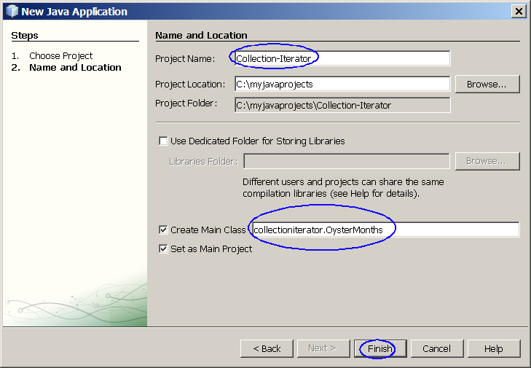
Figure-4.10: Create a new project
- Observe that Collection-Iterator project appears and IDE generated OysterMonths.java is displayed in the source editor window of NetBeans IDE.
2. Modify the IDE generated OysterMonths.java as shown in Code-4.11 below.
package collectioniterator;
import java.util.Collection;
import java.util.ArrayList;
import java.util.Arrays;
import java.util.Iterator;
import java.text.DateFormatSymbols;
public class OysterMonths {
Collection safeMonths;
public Collection filter(Collection c) {
Collection filteredCollection = new ArrayList();
// Creator Iterator object from a Collection object
// and do the iteration.
for (Iterator i = c.iterator(); i.hasNext(); ) {
String s = (String) i.next();
if (condition(s)) {
filteredCollection.add(s);
}
}
return filteredCollection;
}
public boolean condition(String s) {
if (s.contains("r")) {
return true;
}
return false;
}
public static void main(String[] args) {
OysterMonths om = new OysterMonths();
DateFormatSymbols dfs = new DateFormatSymbols();
String[] monthArray = dfs.getMonths();
Collection months = Arrays.asList(monthArray);
om.safeMonths = om.filter(months);
System.out.println("The following months are safe for oysters:");
System.out.println(om.safeMonths);
}
}
Code-4.11: OysterMonths.java
3. Build and run the project
- Right click Collection-Iterator project and select Run.
- Observe the result in the Output window. (Figure-4.12 below)
The following months are safe for oysters:
[January, February, March, April, September, October, November, December]
Figure-4.12: Result of the running the application
return to top of the exercise

Exercise 5: Sorting, Searching, Shuffling, Data Manipulation
  - Sort a list using natural order
  - Sort a list using Comparator
  - Shuffle a list
  - Data manipulation
  - Binary search

(5.1) Sort a list using natural order
1. Create a NetBeans project
- Select File->New Project (Ctrl+Shift+N). The New Project dialog box appears.
- Under Choose Project pane, select Java under Categories and Java Application under Projects. Click Next.
- Under Name and Location pane, for the Project Name field, type in Sorting-NaturalOrder as project name.
- For Create Main Class field, take the IDE filled in value, sortingnaturalorder.Main.
- Click Finish.
- Observe that Sorting-NaturalOrder project appears and IDE generated Main.java is displayed in the source editor window of NetBeans IDE.
2. Modify the IDE generated Main.java as shown in Code-5.11 below. Study the code by paying special attention to bold-fonted code fragments.
package sortingnaturalorder;
import sortingnaturalorder.Name;
import java.util.Arrays;
import java.util.Collections;
import java.util.List;
public class Main {
public static void main(String[] args) {
// Set up test data
String n[] = {
new String("John"),
new String("Karl"),
new String("Groucho"),
new String("Oscar")
};
// Create a List from an array
List l = Arrays.asList(n);
// Perform the sorting operation
Collections.sort(l);
System.out.println("Sorting list of strings = " + l);
// Set up test data
Integer int1[] = {
new Integer(56),
new Integer(78),
new Integer(34),
new Integer(10)
};
// Create a List from an array
List l2 = Arrays.asList(int1);
// Perform the sorting operation
Collections.sort(l2);
System.out.println("Sorting list of numbers = " + l2);
}
}
Code-5.11: Main.java
3. Build and run the project
- Right click Sorting-NaturalOrder project and select Run.
- Observe the result in the Output window. (Figure-5.12 below)
Sorting list of strings = [Groucho, John, Karl, Oscar]
Sorting list of numbers = [10, 34, 56, 78]
Figure-5.12: Result of the running the application
return to top of the exercise

(5.2) Sort a list using Comparator
1. Create a NetBeans project
- Select File->New Project (Ctrl+Shift+N). The New Project dialog box appears.
- Under Choose Project pane, select Java under Categories and Java Application under Projects. Click Next.
- Under Name and Location pane, for the Project Name field, type in Sorting-Comparator as project name.
- For Create Main Class field, take the IDE filled in value, sortingcomparator.Main.
- Click Finish.
- Observe that Sorting-Comparator project appears and IDE generated Main.java is displayed in the source editor window of NetBeans IDE.
2. Modify the IDE generated Main.java as shown in Code-5.11 below. Study the code by paying special attention to bold-fonted code fragments.
package sortingcomparator;
import java.util.ArrayList;
import java.util.Arrays;
import java.util.Collections;
import java.util.Comparator;
public class Main {
public static void main(String[] args) {
// Create an ArrayList object and add items to it.
ArrayList a1 = new ArrayList();
a1.add("Boston");
a1.add("New York");
a1.add("Seoul");
a1.add("Tokyo");
a1.add("London");
a1.add("Bangkok");
System.out.println("Before sorting = " + a1);
// Get String Comparator object and sort the list
Comparator comp = Comparators.stringComparator();
Collections.sort(a1, comp);
// Display the sorted list
System.out.println("Sorted list using String Comparator = " + a1);
// Create an ArrayList object and add items to it.
ArrayList a2 = new ArrayList();
a2.add(new Integer(33));
a2.add(new Integer(17));
a2.add(new Integer(45));
a2.add(new Integer(100));
a2.add(new Integer(3));
System.out.println("Before sorting = " + a2);
// Get Integer Comparator object and sort the list
Comparator comp2 = Comparators.integerComparator();
Collections.sort(a2, comp2);
// Display the sorted list
System.out.println("Sorted list using Integer Comparator = " + a2);
}
}
Code-5.11: Main.java
3. Write Comparators.java.
package sortingcomparator;
import java.util.Comparator;
import java.util.Date;
public class Comparators {
// String Comparator object
public static Comparator stringComparator() {
return new Comparator() {
public int compare(Object o1, Object o2) {
String s1 = (String)o1;
String s2 = (String)o2;
int len1 = s1.length();
int len2 = s2.length();
int n = Math.min(len1, len2);
char v1[] = s1.toCharArray();
char v2[] = s2.toCharArray();
int pos = 0;
while (n-- != 0) {
char c1 = v1[pos];
char c2 = v2[pos];
if (c1 != c2) {
return c1 - c2;
}
pos++;
}
return len1 - len2;
}
};
}
// Integer Comparator object
public static Comparator integerComparator() {
return new Comparator() {
public int compare(Object o1, Object o2) {
int val1 = ((Integer)o1).intValue();
int val2 = ((Integer)o2).intValue();
return (val1<val2 ? -1 : (val1==val2 ? 0 : 1));
}
};
}
// Date Comparator object
public static Comparator dateComparator() {
return new Comparator() {
public int compare(Object o1, Object o2) {
long val1 = ((Date)o1).getTime();
long val2 = ((Date)o2).getTime();
return (val1<val2 ? -1 : (val1==val2 ? 0 : 1));
}
};
}
}
Code-5.12: Comparators.java
4. Build and run the project
- Right click Sorting-Comparator project and select Run.
- Observe the result in the Output window. (Figure-5.13 below)
Before sorting = [Boston, New York, Seoul, Tokyo, London, Bangkok]
Sorted list using String Comparator = [Bangkok, Boston, London, New York, Seoul, Tokyo]
Before sorting = [33, 17, 45, 100, 3]
Sorted list using Integer Comparator = [3, 17, 33, 45, 100]
Figure-5.13: Result of the running the application
return to top of the exercise

(5.3) Shuffle a list
1. Create a NetBeans project
- Select File->New Project (Ctrl+Shift+N). The New Project dialog box appears.
- Under Choose Project pane, select Java under Categories and Java Application under Projects. Click Next.
- Under Name and Location pane, for the Project Name field, type in Shuffling as project name.
- For Create Main Class field, take the IDE filled in value, shuffling.Main.
- Click Finish.
- Observe that Shuffling project appears and IDE generated Main.java is displayed in the source editor window of NetBeans IDE.
2. Modify the IDE generated Main.java as shown in Code-5.31 below. Study the code by paying special attention to bold-fonted code fragments.

package shuffling;
import java.util.Arrays;
import java.util.Collections;
import java.util.List;
public class Main {
public static void main(String[] args) {
// Set up testing data
String name[] = {
new String("Sang"),
new String("Shin"),
new String("Boston"),
new String("Passion"),
new String("Shin"),
};
// Create a List object from an array
List l = Arrays.asList(name);
System.out.println("Before shuffling = " + l);
// Shuffle the list
Collections.shuffle(l);
System.out.println("Shuffled list = " + l);
// Sort the list
Collections.sort(l);
System.out.println("Sorted list = " + l);
}
}
Code-5.31: Main.java
3. Build and run the project
- Right click Shuffling project and select Run.
- Observe the result in the Output window. (Figure-5.32 below)

Before shuffling = [Sang, Shin, Boston, Passion, Shin]
Shuffled list = [Sang, Passion, Shin, Boston, Shin]
Sorted list = [Boston, Passion, Sang, Shin, Shin]
Figure-5.32: Result
return to top of the exercise

(5.4) Data manipulation
1. Create a NetBeans project
- Select File->New Project (Ctrl+Shift+N). The New Project dialog box appears.
- Under Choose Project pane, select Java under Categories and Java Application under Projects. Click Next.
- Under Name and Location pane, for the Project Name field, type in DataManipulation as project name.
- For Create Main Class field, take the IDE filled in value, datamanipulation.Main.
- Click Finish.
- Observe that DataManipulation project appears and IDE generated Main.java is displayed in the source editor window of NetBeans IDE.
2. Modify the IDE generated Main.java as shown in Code-5.41 below. Study the code by paying special attention to bold-fonted code fragments.

package datamanipulating;
import sortingnaturalorder.Name;
import java.util.Arrays;
import java.util.Collections;
import java.util.List;
public class Main {
public static void main(String[] args) {
// Set up test data
String n[] = {
new String("Boston"),
new String("New York"),
new String("Seoul"),
new String("Shanghai")
};
// Create a List from an array
List l = Arrays.asList(n);
// Perform the sorting operation
Collections.sort(l);
System.out.println("Sorted list = " + l);
// Reverse the list
Collections.reverse(l);
System.out.println("Reversed list = " + l);
}
}
Code-5.41: Main.java
3. Build and run the project
- Right click DataManipulation project and select Run.
- Observe the result in the Output window. (Figure-5.42 below)
Sorted list = [Boston, New York, Seoul, Shanghai]
Reversed list = [Shanghai, Seoul, New York, Boston]
Figure-5.42: Result of the running the application
return to top of the exercise

(5.5) Binary searching
1. Create a NetBeans project
- Select File->New Project (Ctrl+Shift+N). The New Project dialog box appears.
- Under Choose Project pane, select Java under Categories and Java Application under Projects. Click Next.
- Under Name and Location pane, for the Project Name field, type in BinarySearching as project name.
- For Create Main Class field, take the IDE filled in value, binarysearching.Main.
- Click Finish.
- Observe that BinarySearching project appears and IDE generated Main.java is displayed in the source editor window of NetBeans IDE.
2. Modify the IDE generated Main.java as shown in Code-5.51 below. Study the code by paying special attention to bold-fonted code fragments.
package binarysearching;
import java.util.Arrays;
import java.util.Collections;
import java.util.List;
public class Main {
public static void main(String[] args) {
// Set up testing data
String name[] = {
new String("Sang"),
new String("Shin"),
new String("Boston"),
new String("Passion"),
new String("Shin"),
};
// Create a List object
List l = Arrays.asList(name);
// Perform binary search
int position = Collections.binarySearch(l, "Boston");
System.out.println("Position of the searched item = " + position);
}
}
Code-5.51: Main.java
3. Build and run the project
- Right click DataManipulation project and select Run.
- Observe the result in the Output window. (Figure-5.52 below)
Position of the searched item = 2
Figure-5.52: Result of the running the application
return to top of the exercise

Homework

1. The homework is to create a NetBeans project as following. (You can name the homework project in any way you want but here I am going to call it MyCollectionProject.)
- Create your own HashSet object
- Add the following objects with properly initialized values to the newly created HashSet object
  - 2 String objects
  - 2 MyOwnClass object (You will have to create MyOwnClass.java first)
    - MyOwnClass class has name (String type) and age (int type)
  - 3 Integer ojbects
- Create Iterator object from the HashSet object and iterate them to get displayed
- Repeat the above for LinkedHashSet, ArrayList
http://personales.unican.es/corcuerp/java/Labs/LAB_17.htm

